附件3：全国高职高专英语写作大赛样题
- 议论文写作（Argumentative Writing）50%
Sample task 1
You happened to see a post by an international student Jennifer Carlson sharing her travel experience on the social media of your university, which was commented on by another international student Jack Brown:
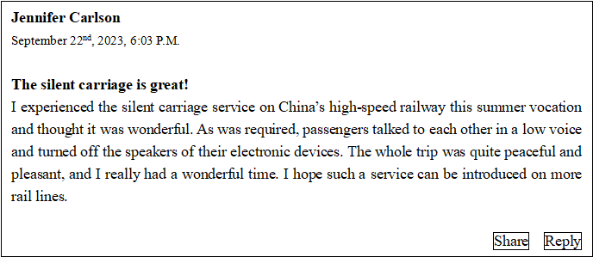
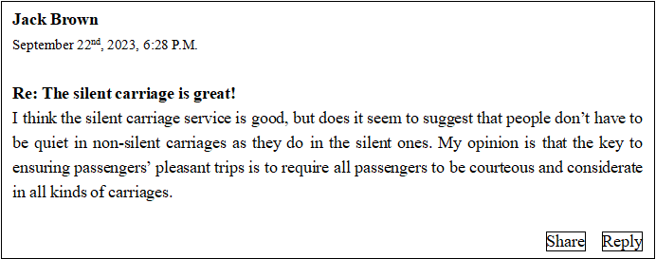

Write your opinions about the contradictory views on the silent carriage service with reasons and examples. You should write between 300 and 400 words.

- 说明文写作（Expository Writing） 50%
Sample task 2
As an intern at an international agricultural development agency, you are asked to write a report based on the following chart on food insecurity published by the Food and Agriculture Organization (FAO). The objective of the report is to summarize the information presented in the chart by selecting and reporting the main features and making relevant comparisons wherever necessary and possible. Your report should be between 300 and 400 words.
Percentage of the World Population Experiencing Food Insecurity
at Moderate and Severe Level, 2018-2020
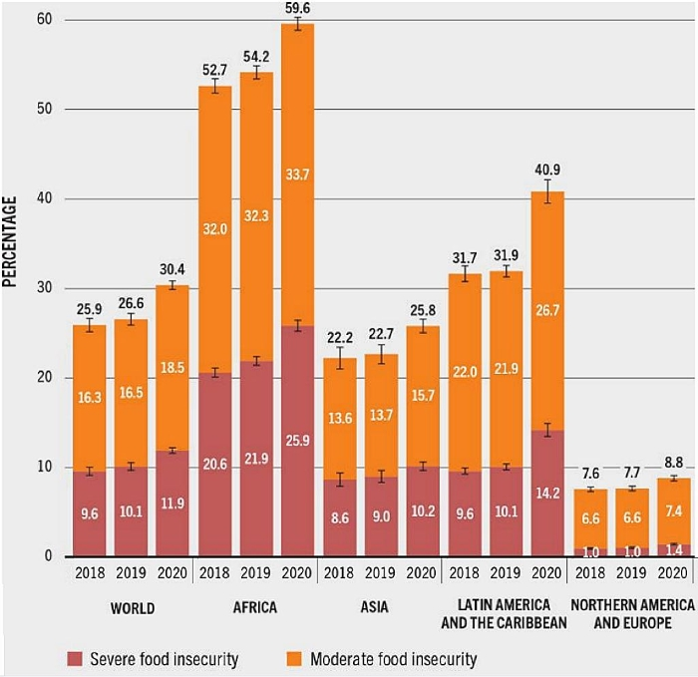
Source: “The State of Food Security and Nutrition in the World 2021” released by the FAO.

Notes:
1. Moderate food insecurity is typically associated with the inability to regularly eat healthy, balanced diets; severe food insecurity implies a high probability of reduced food intake and therefore can lead to more severe forms of undernutrition, including hunger.
2. Differences in totals are due to rounding of figures to the nearest decimal point (四舍五入).

